Jonathan Yang

Assignment 2

Birthday Class

**Test Case 2**

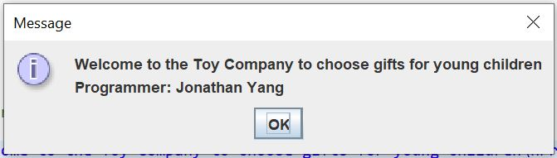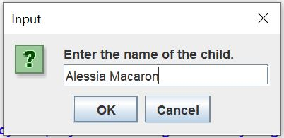

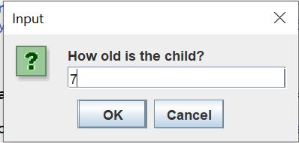

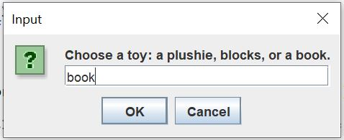

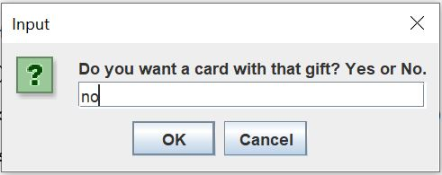

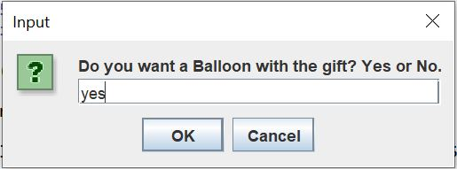

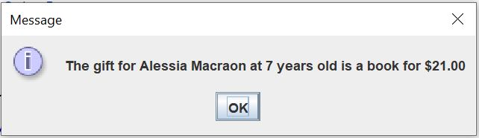

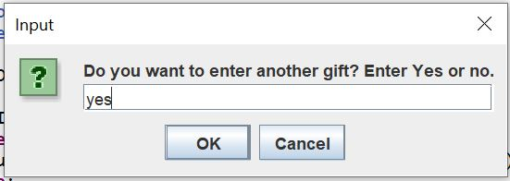

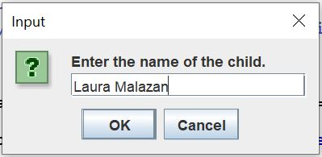

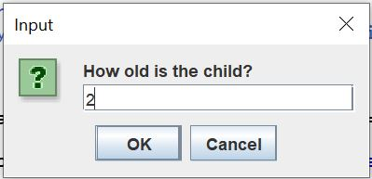

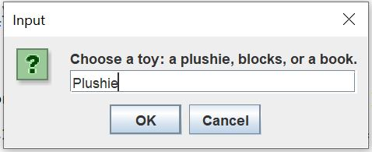

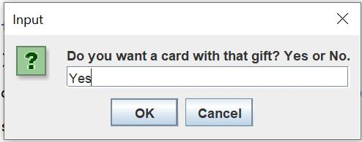

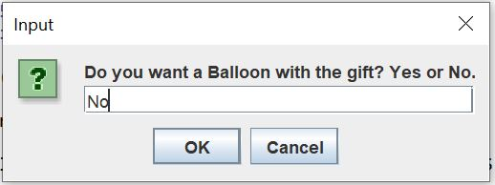

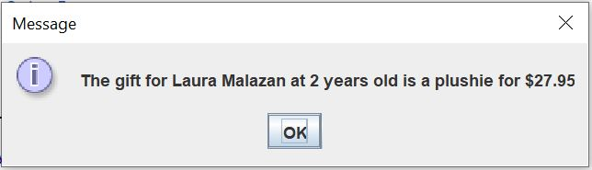

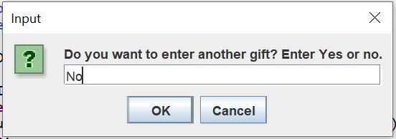

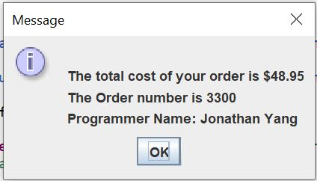

|  |  |  |  |  |  |
| --- | --- | --- | --- | --- | --- |
| Test Case # | Input | Actual Input | Expected Output | Actual Output | Did the test pass? |
| Test Case 2 | Name:  Alessia Macaron  Age:  7  Toy:  Book  Cards:  No  Balloon:  Yes  Name:  Laura Malazan  Age:  2  Toy:  Plushie  Cards:  Yes  Balloon:  No | Name:  Alessia Macaron  Age:  7  Toy:  Book  Cards:  No  Balloon:  Yes  Name:  Laura Malazan  Age:  2  Toy:  Plushie  Cards:  Yes  Balloon:  No | Age Ok:  Yes  Alessia Cost:  21.00  Age Ok:  Yes  Laura Cost:  27.95  Total Cost:  48.95 | Age Ok:  Yes  Alessia Cost:  21.00  Age Ok:  Yes  Laura Cost:  27.95  Total Cost:  48.95 | Passed |